Problem: Has COVID-19 cases and deaths affected the stock and cryptocurrency markets?

For each day plot:

1. Nasdaq daily close and the number of new cases (globally and in the USA)  
   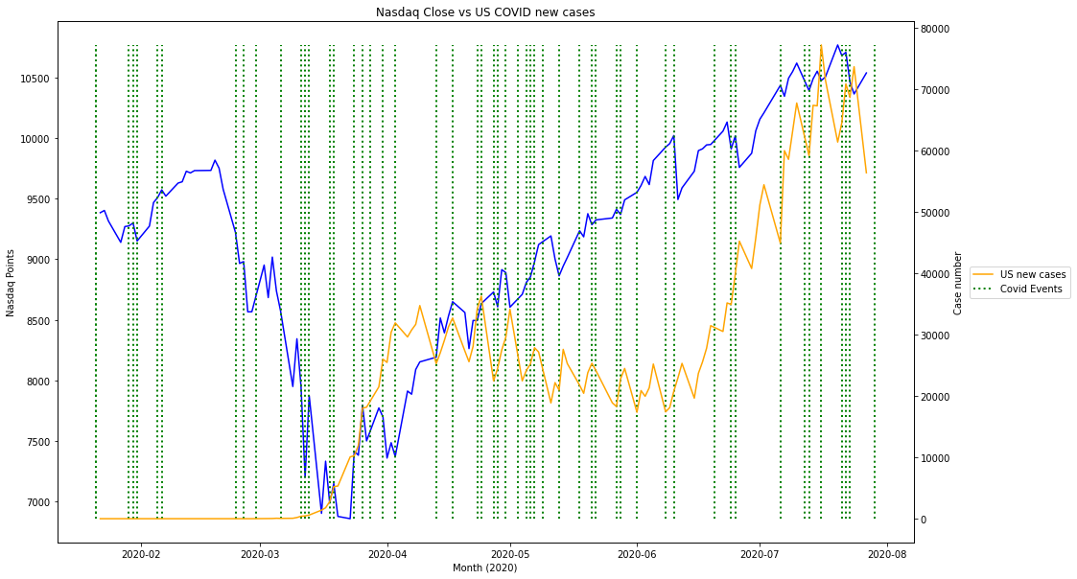 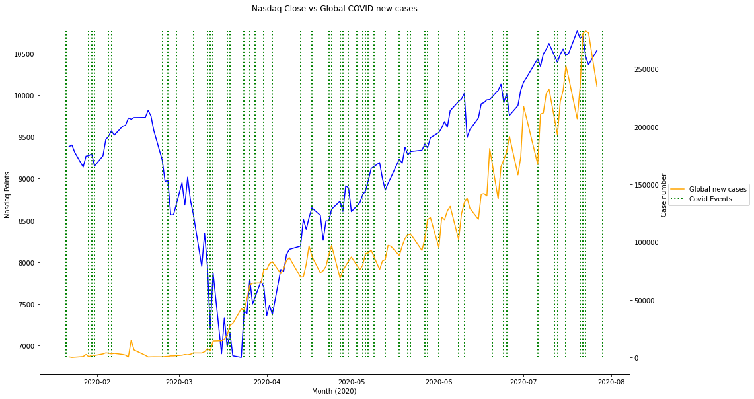
2. Nasdaq daily close vs number of new deaths (globally and in the USA)  
   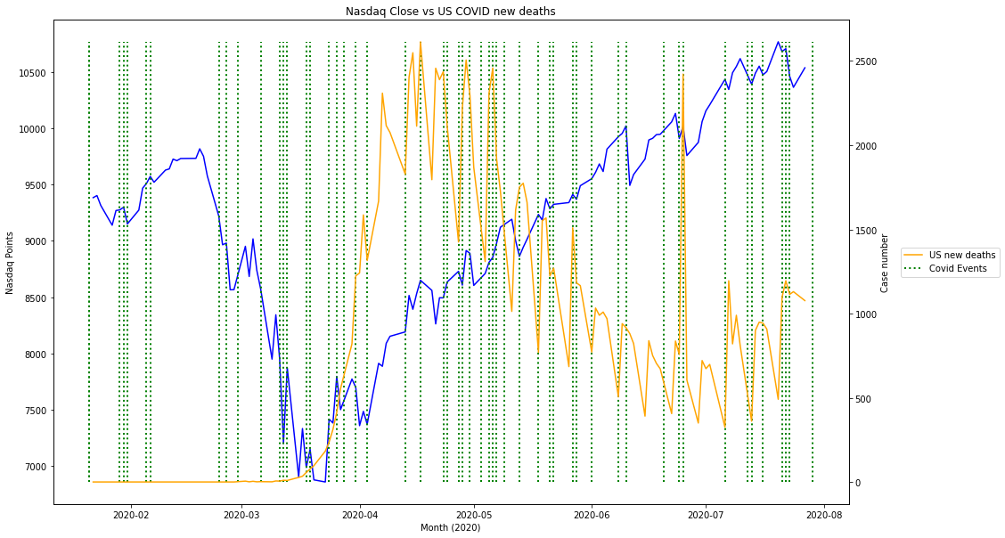 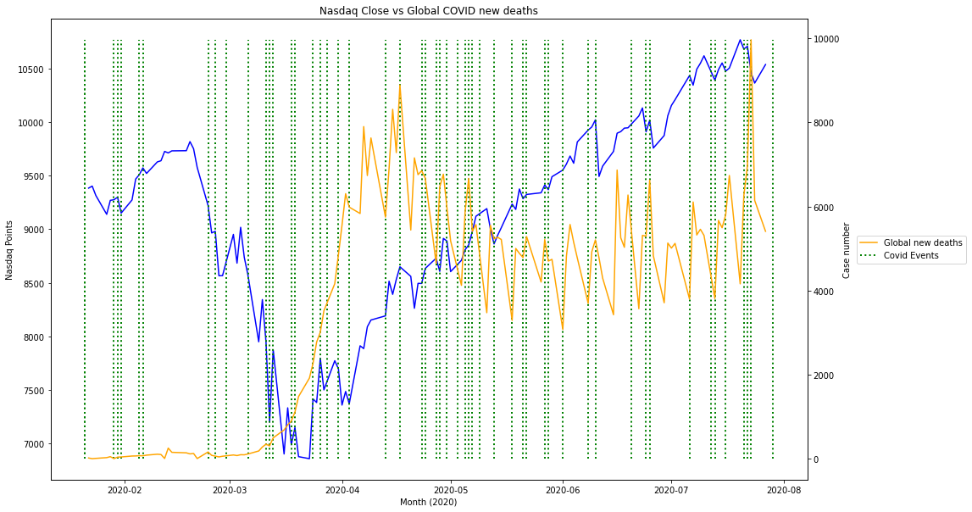
3. Bitcoin daily close and the number of new cases (globally and in the USA)  
    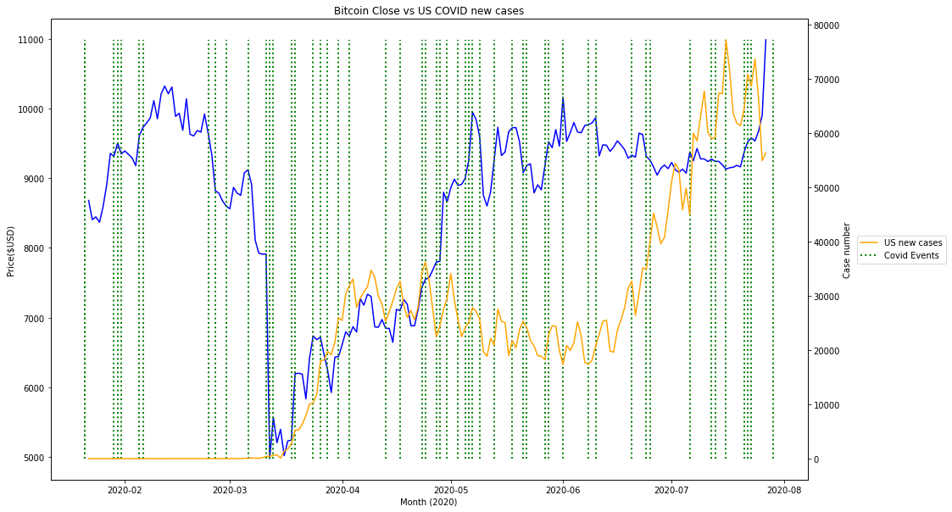 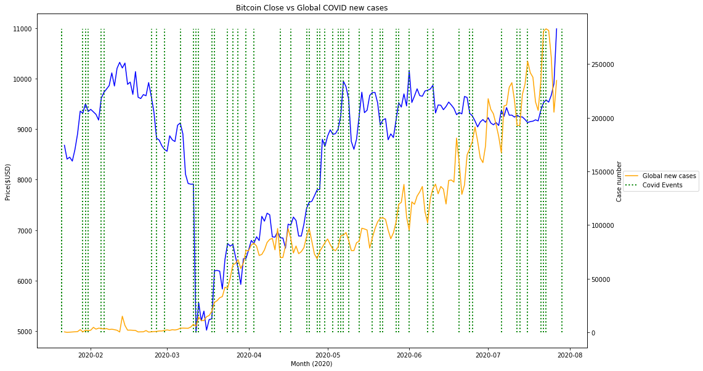
4. Bitcoin daily close vs number of new deaths (globally and in the USA)  
   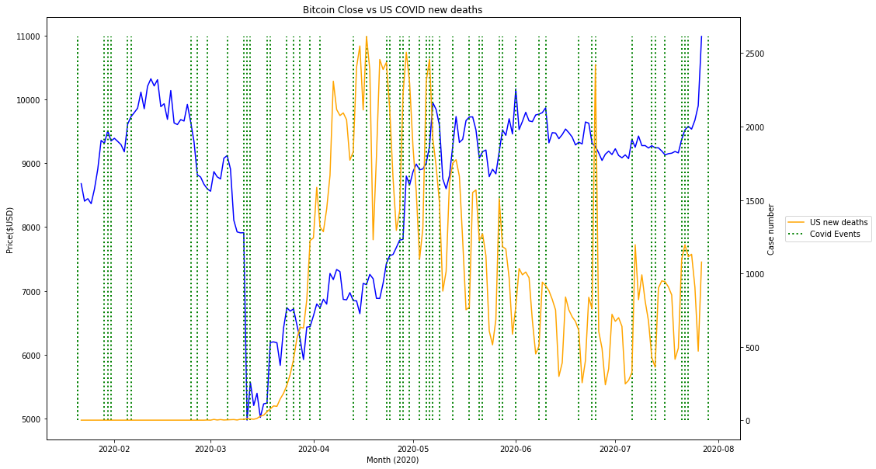 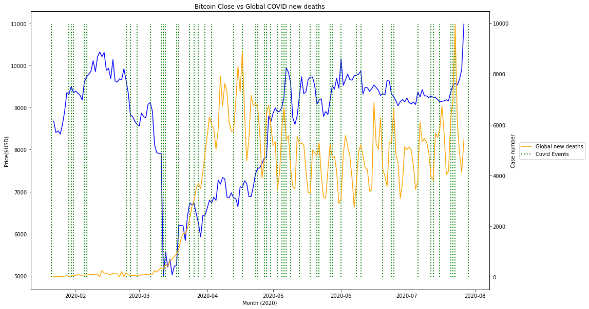
5. Nasdaq daily close and the number of total cases (globally and in the USA)  
   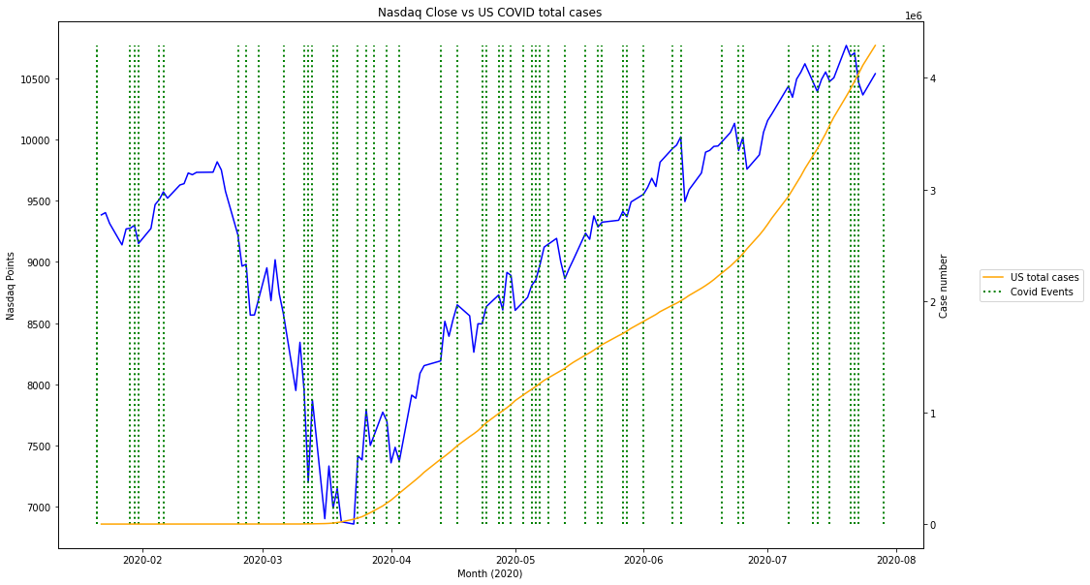 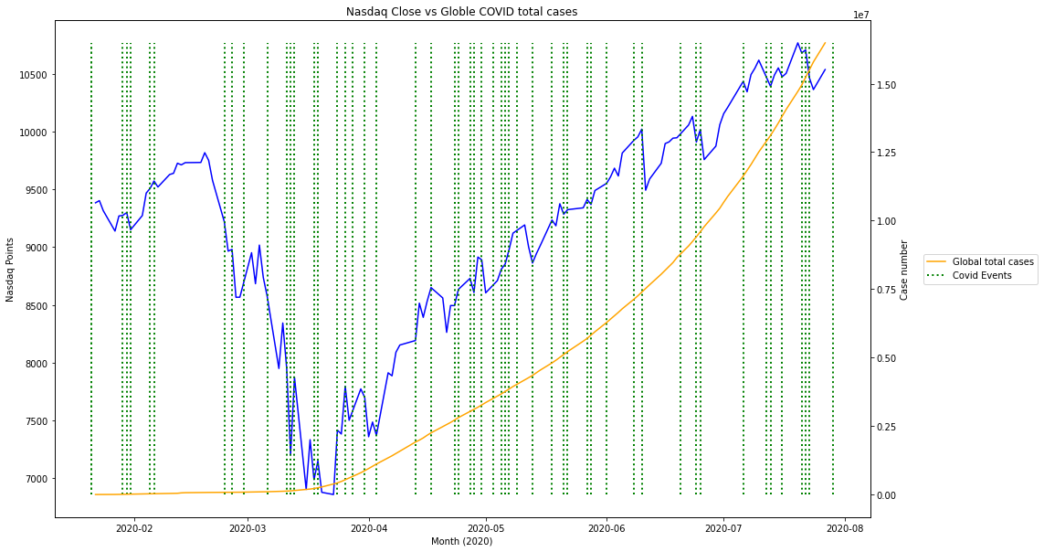
6. Nasdaq daily close vs number of total deaths (globally and in the USA)  
   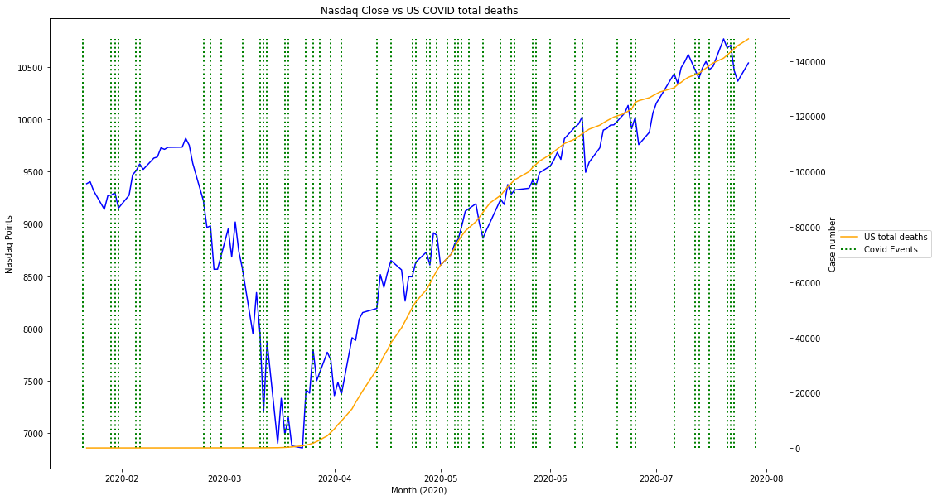 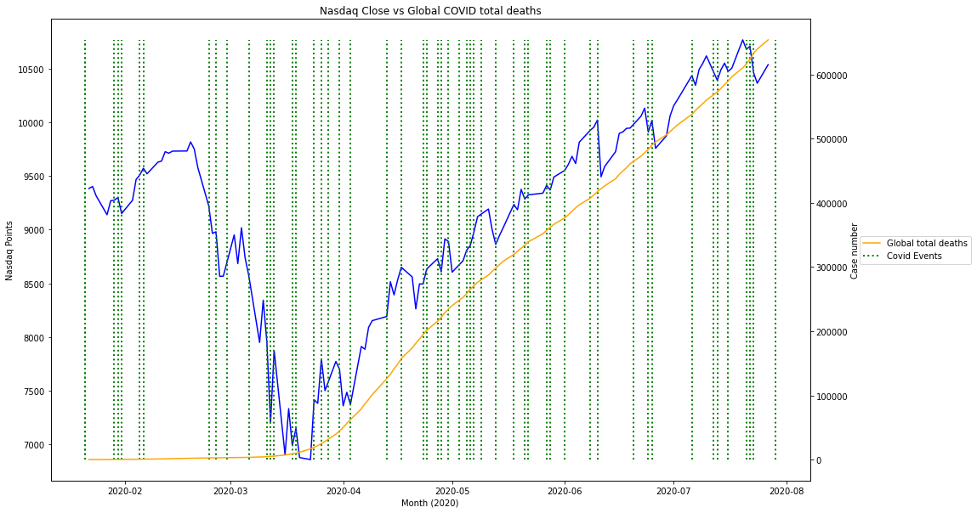
7. Bitcoin daily close and the number of total cases (globally and in the USA)  
   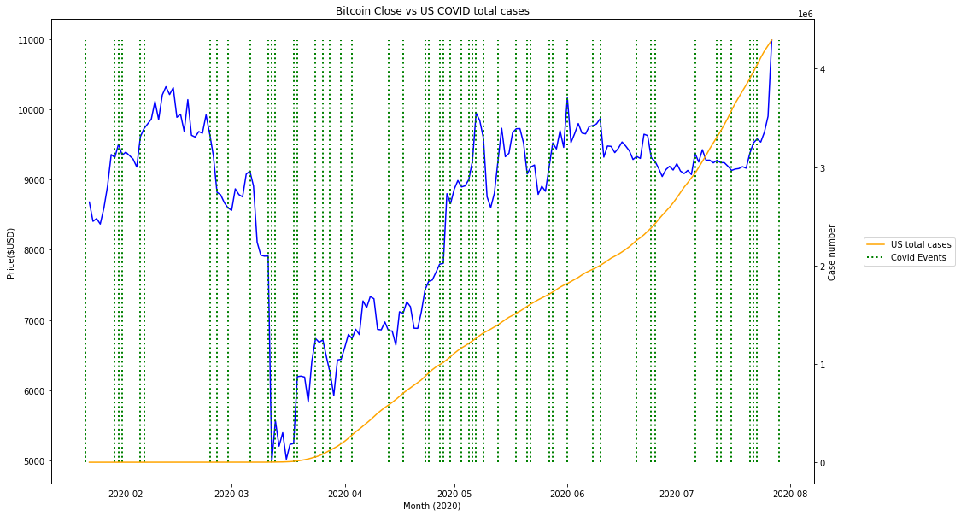 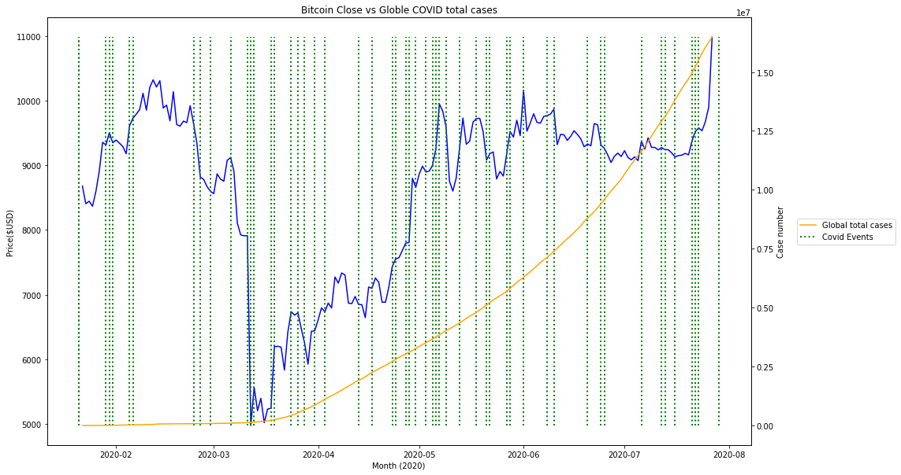
8. Bitcoin daily close vs number of total deaths (globally and in the USA)  
   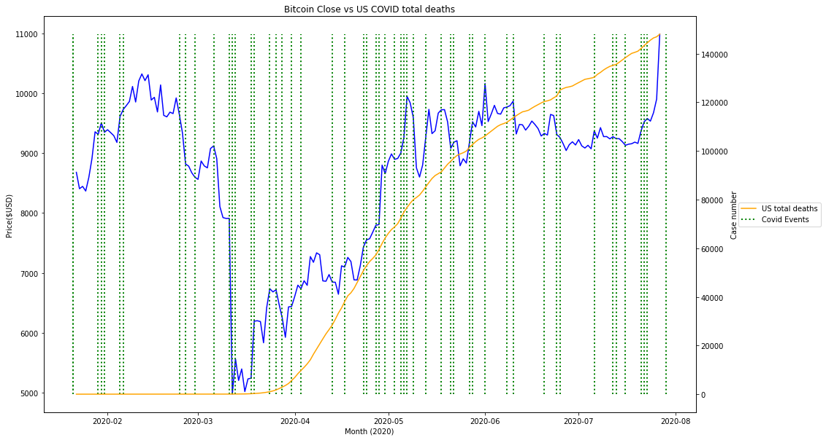 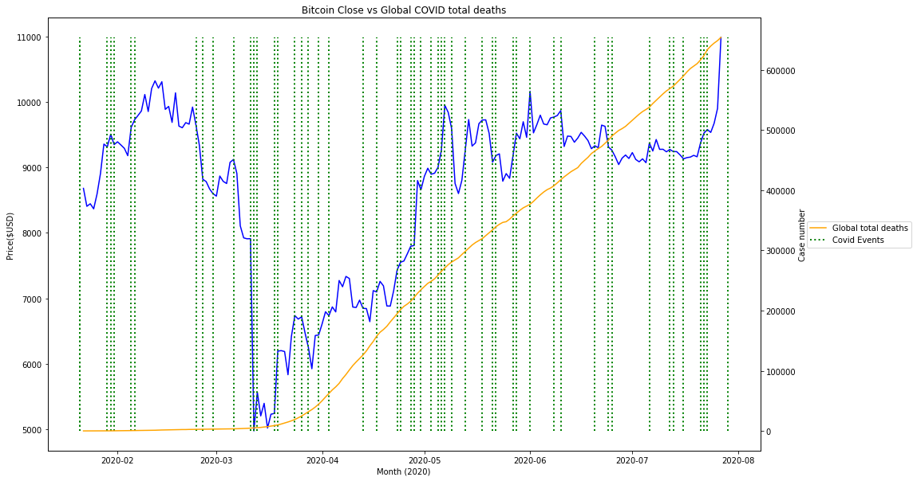

for volume instead of prices

1. Nasdaq daily volume and the number of new cases (globally and in the USA)  
   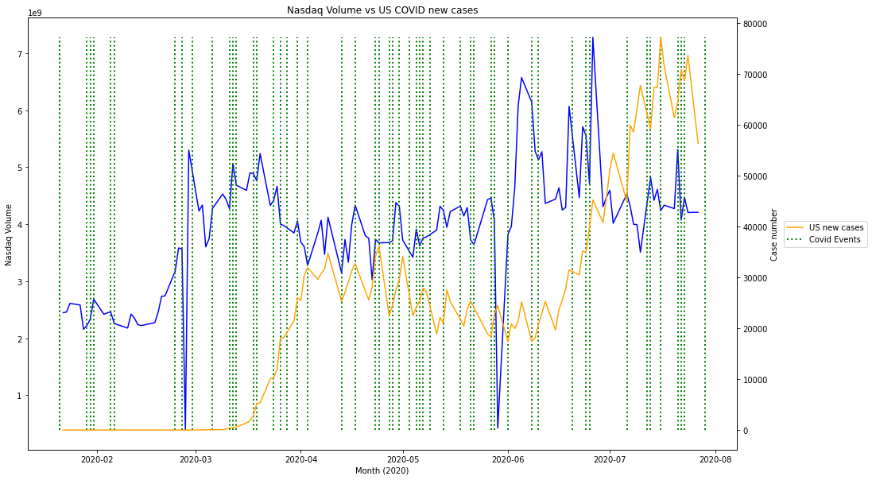 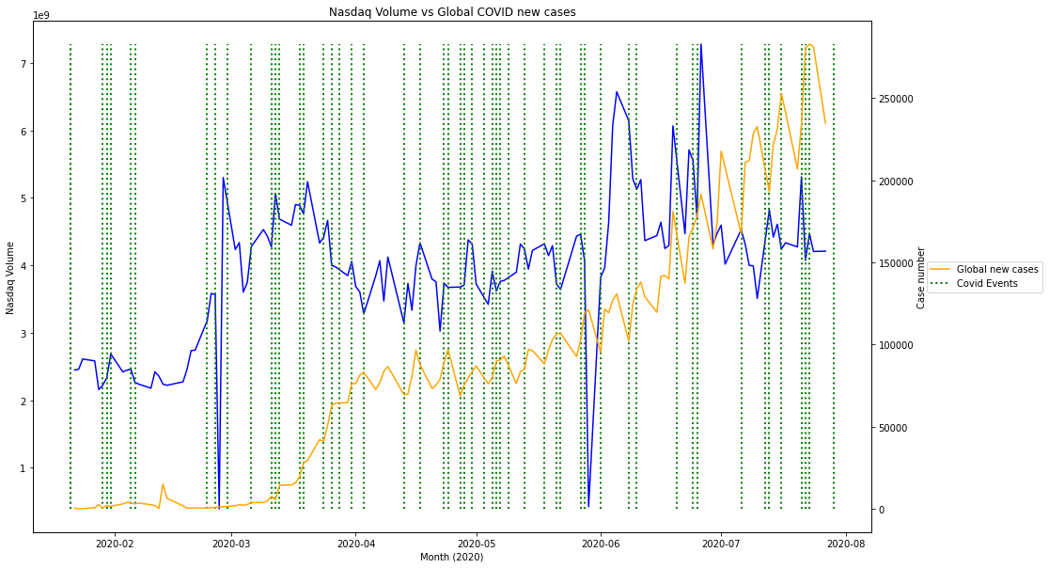
2. Nasdaq daily volume vs number of new deaths (globally and in the USA)  
   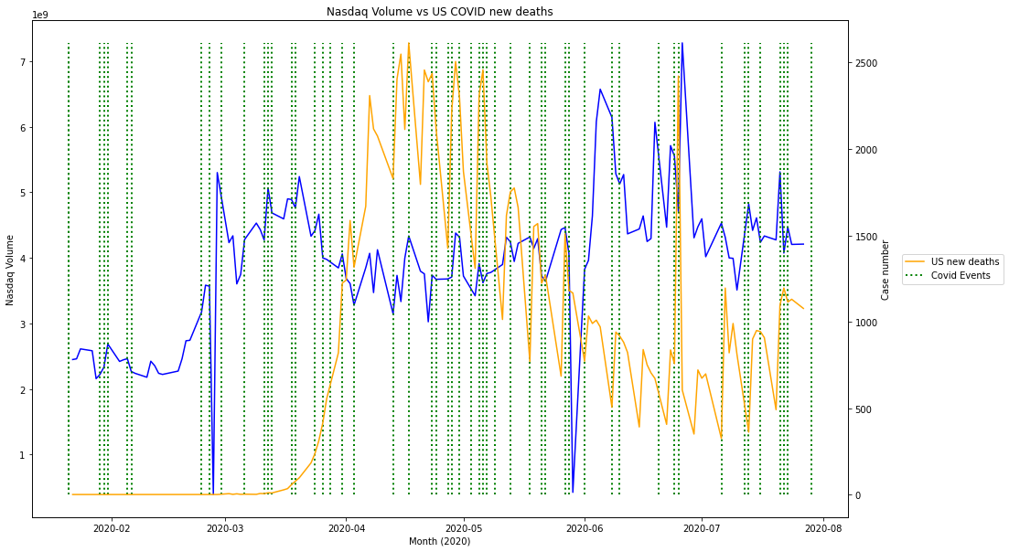 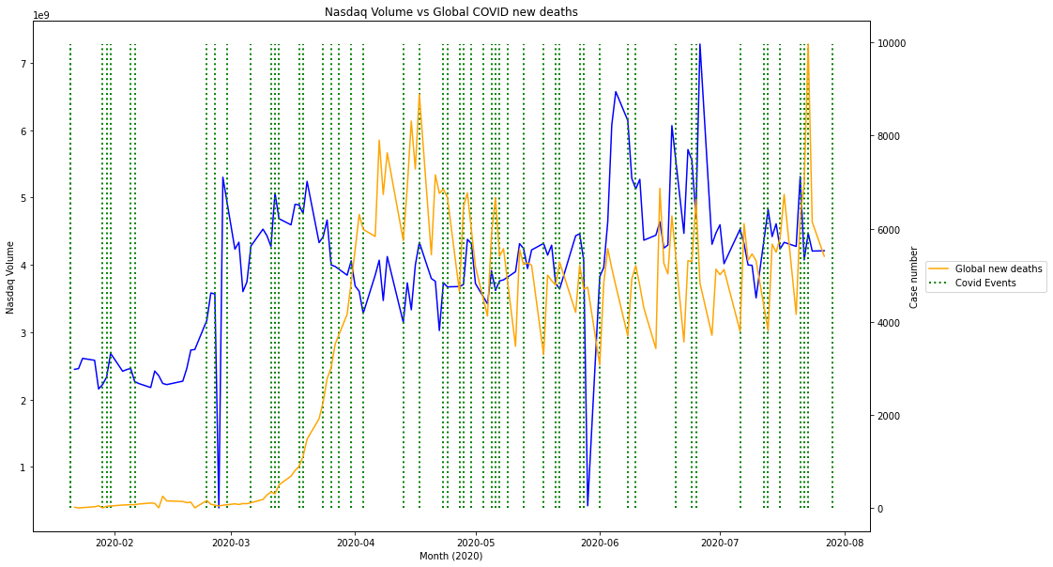
3. Bitcoin daily volume and the number of new cases (globally and in the USA)  
   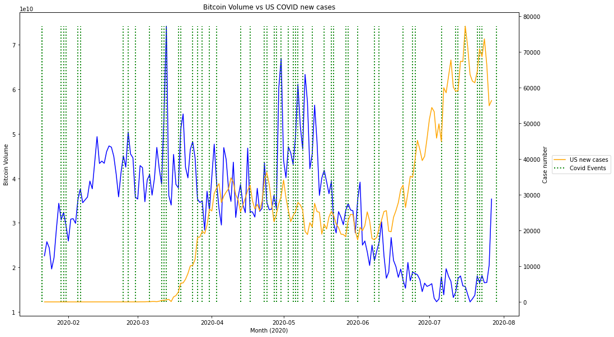 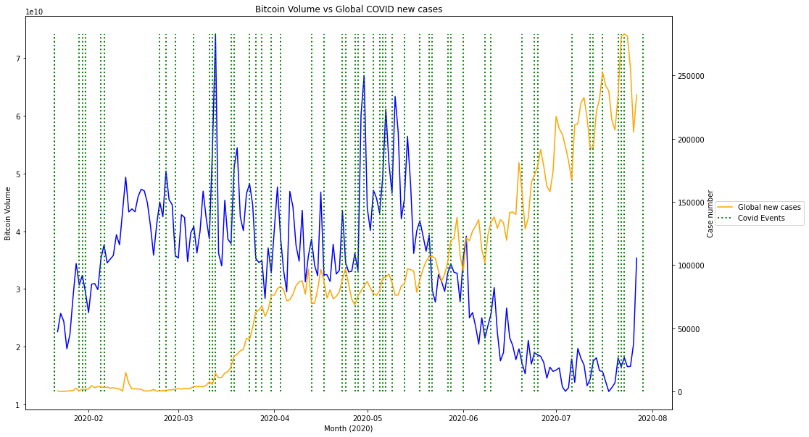
4. Bitcoin daily volume vs number of new deaths (globally and in the USA)  
   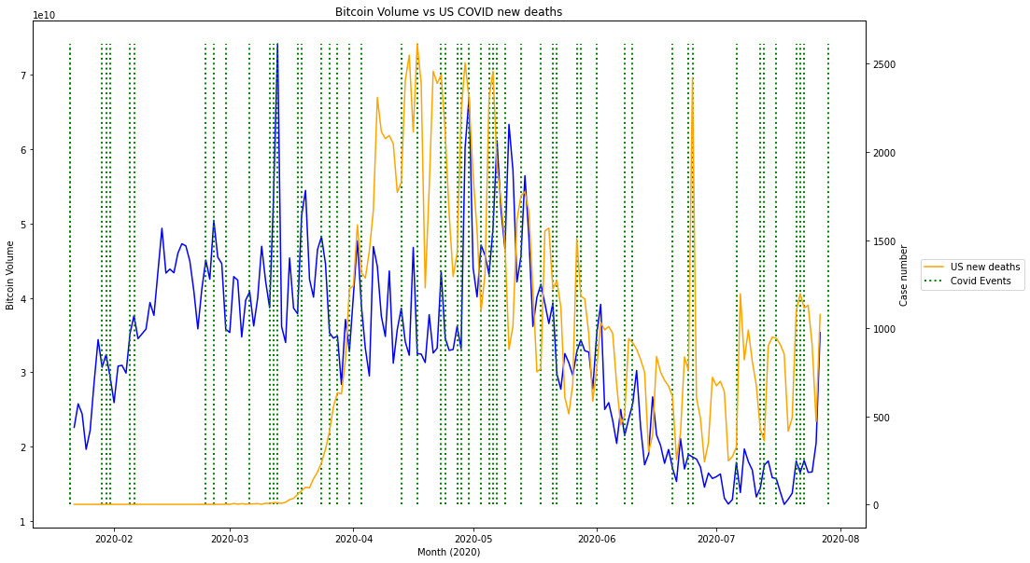 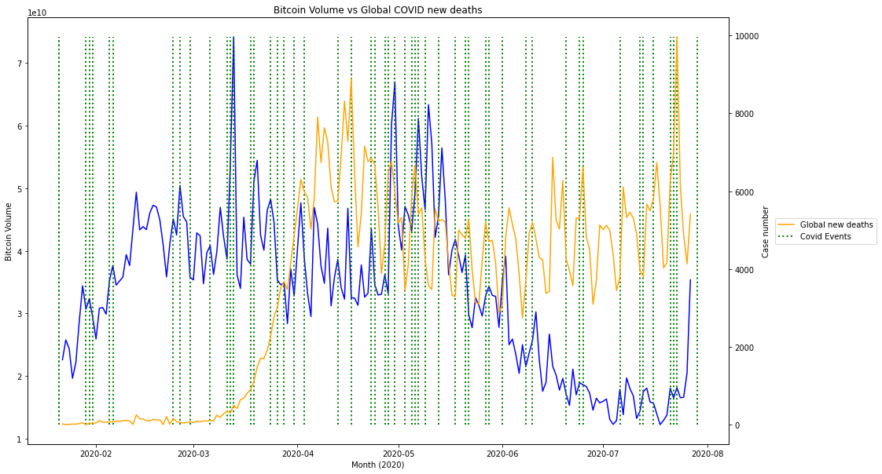
5. Nasdaq daily volume and the number of total cases (globally and in the USA)  
   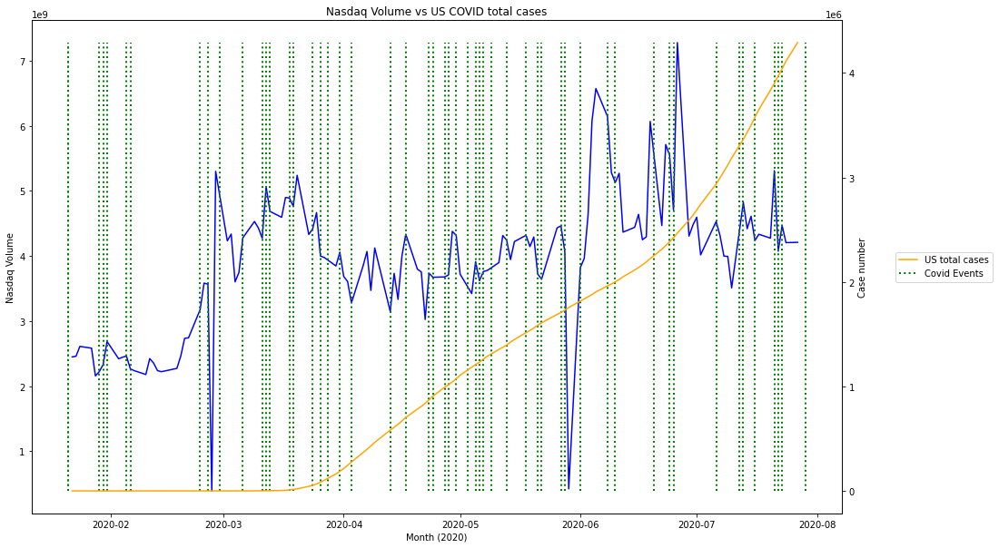 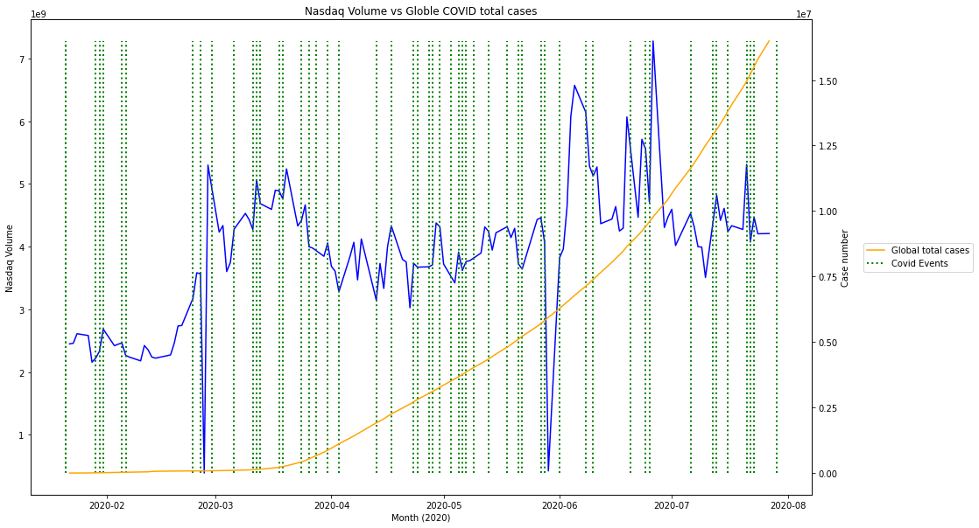
6. Nasdaq volume vs number of total deaths (globally and in the USA)  
   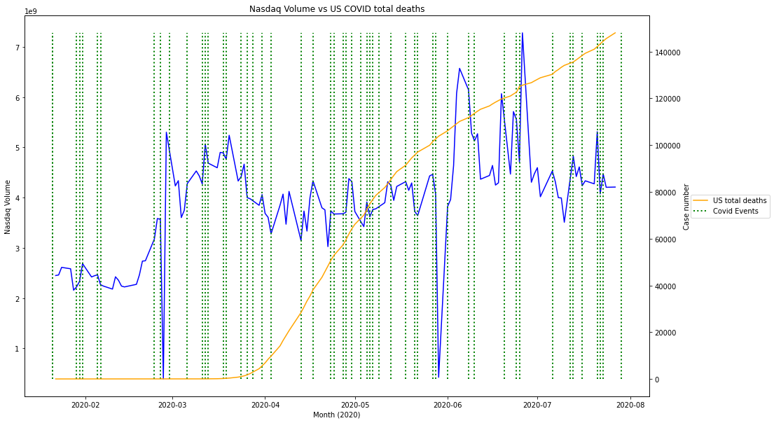 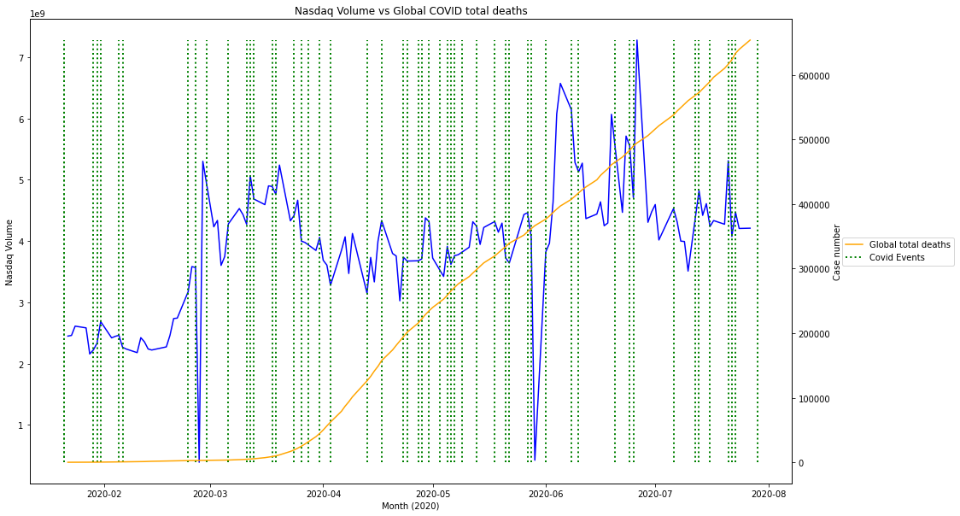
7. Bitcoin daily volume and the number of total cases (globally and in the USA)  
   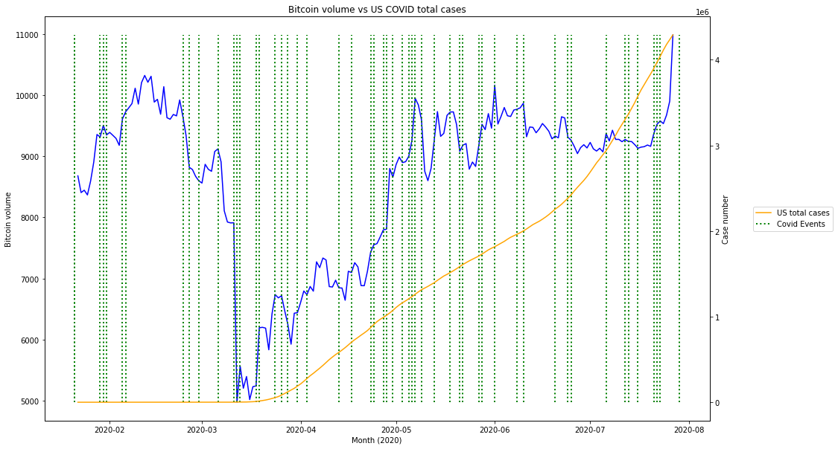 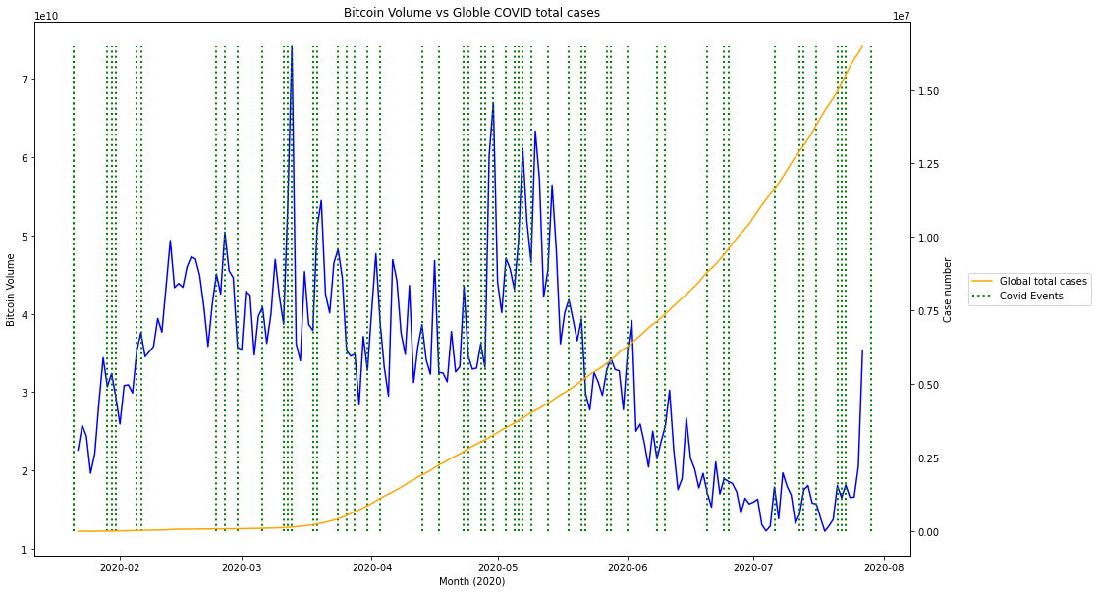
8. Bitcoin daily volume vs number of total deaths (globally and in the USA)  
   